# NAME OF INVENTOR:

1. Prajes Das
2. Sukalyan Chakraborty
3. Dr. Shubhendu Banerjee

# ADDRESS OF APPLICANT:

81, Nilgunj Rd, Jagarata Pally, Deshpriya Nagar, Agarpara, Kolkata, West Bengal 700109

# NAME OF APPLICANT:

Narula Institute of Technology

# TITLE:

MediTrack: Smart Pill Dispenser for Elderly Care

|  |  |  |  |
| --- | --- | --- | --- |
| SL. NO. | NAME OF INVENTORS | PHOTO OF INVENTOR | SIGNATURE |
| 1 | Prajes Das |  |  |
| 2 | Sukalyan Chakraborty |  |  |
| 3 | Mr. Shubhendu Banerjee | C:\Users\HP3\Desktop\393827886_7019633464725692_7642264019020296011_n.jpg |  |

# DETAILS OF INVENTOR

# Field of the invention:

The innovation relates to health care technology, with a particular emphasis on drug management systems intended to help the elderly. It tackles the difficulties related to medication compliance, which is essential to preserving the health and wellbeing of the senior citizenry. This smart pill dispenser combines state-of-the-art technology with an intuitive design to guarantee that senior citizens take their medications on schedule, in the recommended dosage, and with the least amount of help from others. MediTrack is especially useful in settings like nursing homes, assisted living facilities, and in-home care where there is a strong demand for individualised and closely monitored treatment. The idea offers a complete medication management solution by fusing aspects of artificial intelligence, the Internet of Things (IoT), and mobile connectivity. MediTrack seeks to improve older people's quality of life and provide family members and carers peace of mind by increasing adherence and lowering the chance of prescription errors. This idea has the potential to revolutionise the way medication administration is done in elder care settings and represents a significant advancement in the field of geriatric care.

# Background of the invention:

Medication non-adherence is still a major problem in healthcare, especially for older patients, people with long-term conditions, and people who are on complicated drug schedules. Inaccurate or missed dosages might result in more hospital stays, worsening of illnesses, and increased medical expenses. Real-time tracking, remote monitoring, and technological integration are frequently absent from conventional pill organisers and reminder systems.The demand for intelligent solutions that not only remind users but also guarantee proper medicine intake and send feedback to carers or medical professionals is rising as a result of the introduction of smart devices and the Internet of Things. Current methods frequently fall short in integrating robust software tracking, user interaction, data analytics, and physical dispensing processes.By developing a Smart Medication Dispenser that combines automatic alerts, real-time dose tracking, user involvement via a mobile app, and adherence reporting, this invention fills these shortcomings. By guaranteeing prompt drug ingestion, recording dosage history, and enabling remote supervision, the system improves patient safety and fosters improved health outcomes.

# Summary of the invention:

MediTrack is a clever, Internet of Things-enabled medication management system that was created especially to help senior citizens take their medications on time. It combines artificial intelligence, mobile connectivity, and smart dispensing technologies to give precise dosages, timely reminders, and real-time adherence monitoring. With features like scheduled dispensing, missed dosage alarms, and carer notifications, MediTrack serves as both a physical pill dispenser and a digital companion. By ensuring that drugs are administered in the appropriate amounts and at the appropriate times, the method considerably lowers the possibility of mistakes or missing doses. Family members and carers can remotely check adherence, get notifications for missed or late doses, and modify medication schedules as necessary via its mobile application. The solution is perfect for usage in assisted living facilities, nursing homes, and home care settings because it gives older people their independence while also giving carers peace of mind. By providing an automated, linked, and user-friendly solution, MediTrack essentially tackles the serious problem of prescription non-adherence among the elderly, boosting overall quality of life, lowering hospital visits, and improving health outcomes.

# 4. Description of the invention: (including flow diagram, results, etc.)

In order to improve drug adherence in older patients and those with long-term medical issues, this invention presents a brand-new smart medication dispenser. The gadget, which is essentially a rotatory carousel mechanism, is designed to hold medication blister packs and rotate the required medication into place so that the user can retrieve it at predetermined periods. The combination of artificial intelligence, real-time sensor monitoring, and seamless carer communication sets this innovation apart from previous art and provides not just automated dispensing but also proactive, intelligent healthcare intervention.

The ESP32 microcontroller, which is the foundation of the system, was selected for its powerful processing power and built-in Wi-Fi module, which guarantees constant contact with the mobile application. The device uses a high-precision Real-Time Clock (RTC), usually the DS3231 module, to maintain precise scheduling. This RTC operates independently of power variations, guaranteeing that time-sensitive operations continue to run consistently. Through onboard controls, which include bright OLED display and tactile push buttons, users or carers can interact with the device directly or remotely through a mobile application. Both tech-savvy users and those with low levels of digital literacy may utilise the system efficiently because to its dual accessibility structure, which also offers flexibility.

The carer or user programs the medication regimen in the beginning, indicating the kind of medication and when to take it. These settings are kept in the memory of the microcontroller and are constantly checked against the real-time data from the RTC. The system starts a multi-step dispensing sequence at each predetermined time. First, a buzzer and LED lights act as audio-visual notifications to grab the user's attention, and the OLED screen clearly indicates which drug is due. The relevant blister pack is then rotated into alignment with the dispensing window by the carousel, which is powered by a high-torque servo or stepper motor.

The actual carousel is a circular platform with uniformly sized sections that can each hold a blister pack of standard size. A multi-dose blister strip can fit inside each slot, which normally has dimensions of roughly 70 mm in width, 120 mm in length, and 12 mm in depth. With a total diameter of 250–300 mm, the carousel can accommodate 7–14 different types of medications. To ensure exact slot alignment, it is positioned on a central rotating shaft that is supported by bearings and indexed using magnetic sensors or optical encoders.

An access window or gate prompts the user to retrieve their medication after the proper slot is lined up. For security and hygienic reasons, this mechanism might have a sliding cover or a spring-loaded trap door. A light-dependent resistor (LDR) or comparable light sensor is placed in close proximity to the dispensing hole to verify that the user has taken the medication. The abrupt shift in light intensity that occurs when a tablet is removed is recognised and recorded as a successful dosage event. The system considers a missed dose if no pill is retrieved within the allotted period, which is usually five minutes.

When this happens, the ESP32 starts a notification routine right away, alerting the caregiver's mobile app. Depending on the user's option, these notifications can be set up as emails, SMS messages, or push alerts. Because of this closed-loop communication, carers are always aware of adherence breaches and are able to take appropriate action. In addition, each dose—whether taken or missed—is recorded and timestamped in the system, generating an extensive adherence history that can be accessed through the app.

Manual interaction is also supported by the device. The push buttons allow users to manually verify adherence, browse status menus, or request an ad hoc dose. With its large lettering and high contrast images on the OLED screen, the interface was created with accessibility in mind. For older users or those with eyesight or dexterity impairments, these features are especially important.   
The device is equipped with a strong power backup mechanism to guarantee continuous functioning, particularly in areas with unstable electricity. A rechargeable lithium-ion battery serves as the main power source, while a backup coin-cell battery that maintains RTC functionality is optional. Even during prolonged power outages, the system will continue to operate and maintain precise time thanks to this layered power design.

A feature-rich mobile application that caters to two main user personas—the patient and the caregiver—complements the hardware. The app serves as a reminder for the patient, alerting them when it's time to take their prescription. To ensure redundancy, the system escalates the reminder via voice calls or SMS if the user does not reply to the push alert. By hitting a noticeable "Taken" button on the app's interface, the user can verify that they have taken the drug. Additionally, a photo can be uploaded as visual evidence of dose adherence. This can be confirmed using AI-based image recognition algorithms that identify the type of pill and compare it to the prescribed dosage.

A thorough dashboard showing real-time adherence measures is included of the caregiver's app version. Reports that show patterns like regularly missed dosages or persistently delayed consumption timings might be produced on a weekly or monthly basis. Additionally, the interface has an override feature that lets carers remotely change schedules, provide emergency doses, or turn off the device if needed.

This invention's AI-enhanced adherence tracking is one of its most unique characteristics. The system examines past user behaviour using time-series analysis methods, including ARIMA models or Long Short-Term Memory (LSTM) neural networks, to identify new non-compliance trends. For example, before adherence deteriorates to a critical degree, the system detects a variation if a user starts routinely skipping morning doses and notifies the carer.

Additionally, the system uses reinforcement learning models or clustering algorithms like K-means for adaptive scheduling optimisation. In order to suggest new medication schedules that better suit the user's lifestyle, these algorithms analyse user interaction patterns. The system might recommend changing the schedule to accommodate a patient's natural tendency to postpone their 6 PM medication until 6:30 PM, for instance, which would increase overall compliance.

Using lightweight NLP models processed on-device using TensorFlow Lite to enable voice-based interaction is another noteworthy feature. This enables users to communicate with the device with basic voice commands like "Remind me in 10 minutes" or "When is my next dose?" The system generates human-like, sympathetic, and educational answers to these queries, either locally or via a cloud-based AI engine.

The device's mechanical design prioritises modular scalability and user-friendliness. The outer shell, which is composed of sturdy PLA or ABS plastic, has a hinged lid that makes it simple to reach the carousel while refilling. To reduce exposure to impurities and make maintenance easier, the electronics are kept in a compartment underneath the spinning platform. Because of its small size—it usually measures 300 mm in width and depth and 160 mm in height—it can be placed on kitchen countertops or bedside tables.

Consider a common user scenario to demonstrate how the gadget works: a carer creates a schedule that dictates that Pill A should be taken at 8:00 AM and Pill B at 6:00 PM every day. The carousel lines up the proper blister pack with the dispensing window at 8:00 AM, the buzzer sounds, and the OLED shows the message, "Take Pill A." A notification is automatically sent to the carer, who can then take the necessary follow-up action, if the person does not retrieve the pill within five minutes. Every incident is recorded in the system and accessible through the caregiver's smartphone interface.

Several schematic diagrams are included with the physical product to help with comprehension and application. These include wireframes of the mobile app's user interface, a block diagram that shows how electronic modules are connected, an exploded view of the carousel that shows each mechanical component, and an example graph from the AI dashboard that shows adherence patterns over time.

This innovation has a number of distinct advantages over prior art. First, instead of just recording non-adherence, it uses AI to forecast and avoid it. Secondly, it facilitates user-adaptive, dynamic scheduling to better match actual behaviour. Third, it provides verification techniques including photo-based AI validation and incorporates voice interaction for accessibility. Fourth, using blister packs makes carer refills easier and preserves the purity of pharmaceuticals. Lastly, it is appropriate for both individual and institutional use due to its scalable, modular design.

# Categories – Component Utilisation for Smart Medication Dispenser

|  |  |  |
| --- | --- | --- |
| Category | Component | Utilisation Description |
| Dimension | Device Size | Approximately 30 cm × 25 cm × 15 cm, optimally designed for tabletop placement, housing the carousel, electronics, and UI components. |
| Weight | Total Device Weight | Estimated at ~1.2 kg, ensuring stability while remaining portable for household or clinical use. |
| Mechanical | Rotatory Carousel | Holds 7–14 blister packs arranged in circular fashion. Controlled by servo motor for positioning the correct dose at the dispensing outlet. |
| Motor System | Servo Motors | High-precision servo motors (SG90/MG996R) control carousel rotation and compartment opening based on scheduled medication time. |
| Processing | ESP32 Microcontroller | Acts as the core processor for schedule tracking, motor control, sensor data reading, and app communication via built-in Wi-Fi and BLE capabilities. |
| Timekeeping | RTC Module (DS3231) | Provides accurate real-time scheduling even during power failure, enabling precise dispensing logic. |
| Power Supply | 18650 Li-ion Battery (x2) | Rechargeable battery system with ~4000 mAh capacity, powering the system for multiple days, supported by power management circuitry for regulated output. |
| Sensor | LDR Sensor | Detects whether the pill was removed from the dispensing slot by sensing light change, thereby confirming intake. |
| Sensor | Push Buttons | Enables manual override of dispensing, schedule navigation, and system setup without relying on mobile app. |
| Indicator | OLED Display (0.96” I2C) | Displays real-time clock, medication prompts, error messages, and user menu for easy interaction. |
| Alert System | Buzzer + LED Indicators | Alerts the user via sound and flashing lights at the scheduled time to take medication, especially helpful for hearing or vision-impaired users. |
| Software | Mobile App (Android) | Allows caregiver/user to set, edit, and sync medication schedules. Receives adherence logs and missed dose alerts. |
| Software | Firebase Realtime DB | Cloud backend used for real-time data synchronization between dispenser and mobile application for adherence tracking and notifications. |
| AI Engine | TensorFlow Lite | Enables on-device execution of lightweight AI models for adherence prediction, schedule optimization, and voice interaction (if implemented). |
| AI Feature | Time-Series Model (LSTM/ARIMA) | Analyzes adherence data to detect patterns of non-compliance and proactively warns caregivers of behavioral deviations. |
| AI Feature | Reinforcement Learning Agent | Learns optimal medication times based on user routines and habits, suggesting adaptive rescheduling for improved compliance. |
| NLP System | Speech Recognition (NLP) | Provides voice interface for users to ask, “When is my next dose?” or issue simple voice commands to interact with the device hands-free. |
| Development | Android Studio + Firebase SDK | Used to build and manage the caregiver-patient mobile app with real-time adherence monitoring and control features. |
| Programming | C++ (ESP32) / Python (AI) | Embedded firmware written in C++ (Arduino/ESP-IDF) for real-time control, Python used for AI model training and adherence analytics module. |
| Dev Platform | VS Code / Arduino IDE | Code development for ESP32 control logic, peripheral interfacing, and OTA update support. |
| Voice UI | Google Speech API / TensorFlow Lite | Enables NLP interaction layer for accessibility, optional for advanced voice command support. |

# Results:

Ensuring consistent medication adherence is one of healthcare's most enduring problems, and the Smart Medication Dispenser with AI-Enabled Adherence Tracking and Rotatory Blister Pack Carousel offers a comprehensive solution. This technology has a revolutionary effect on home healthcare and eldercare settings by fusing mechanical precision, real-time monitoring, cognitive analytics, and user-centric design. Through intelligent automation and carer collaboration, it does more than just administer medication; it learns, adapts, and protects its users' health.

# Advantages over the Prior Art:

In terms of functionality, intelligence, and user-centred design, this invention clearly outperforms current drug delivery systems. By combining real-time adherence monitoring, AI-based behavioural analytics, and a rotary carousel mechanism that works well with blister packs, this device overcomes a number of limitations present in the prior art, in contrast to legacy pill dispensers that usually rely on mechanical timers or basic alarm-based systems.

1. **AI-Driven Predictive Monitoring:** Traditional dispensers log adherence but lack foresight. This system employs time-series models (e.g., LSTM, ARIMA) to proactively detect emerging non-adherence trends. By identifying patterns—such as repeated delays or time-specific dose avoidance—it enables timely caregiver intervention before critical lapses occur.
2. **Adaptive Scheduling Engine:** Existing solutions operate on fixed user-defined schedules. Our system incorporates reinforcement learning and unsupervised clustering to dynamically optimize medication timings based on real-life behavioral patterns. For instance, if the user repeatedly delays a 6:00 PM dose, the system suggests a schedule shift to improve compliance—something prior devices cannot accommodate.
3. **Blister Pack Carousel System:** Most smart dispensers require users to decant pills into custom trays, which introduces hygiene risks and increases setup errors. This invention maintains pharmaceutical integrity by allowing entire blister packs to be loaded directly into the rotatory carousel. Each blister cavity is dispensed intact, minimizing tampering and cross-contamination.
4. **Real-Time Adherence Confirmation:** Prior devices rely on user confirmation (e.g., pressing a button) which can be gamed or forgotten. This system uses light sensors (LDRs) to detect whether a pill has actually been removed, ensuring objective verification. Optionally, AI-driven image recognition further validates intake via user-submitted photos.
5. **Voice-Based Interface for Accessibility:** Legacy devices are often not senior-friendly. This device supports NLP-based voice commands, processed locally or via cloud APIs, allowing visually impaired or digitally inexperienced users to interact intuitively (e.g., “Remind me in 10 minutes”).
6. **Multi-Channel Notification System:** Most dispensers alert users only via local alarms. This invention provides redundant notification pathways including mobile app alerts, SMS, voice calls, and caregiver notifications. This ensures no missed dose goes unnoticed, especially for patients with cognitive decline.
7. **Caregiver Dashboard & Remote Control:** Unlike prior systems with limited caregiver support, this invention offers a dedicated caregiver dashboard with real-time logging, weekly/monthly compliance reports, override capabilities, and trend analysis. This centralizes monitoring for family or clinical staff managing multiple patients.
8. **Scalable and Modular Architecture:** The physical and software architecture is modular, allowing the system to be scaled for multi-user facilities like nursing homes or outpatient centers. Prior art often lacks the flexibility for institutional deployment.
9. **Battery Backup with RTC Isolation:** In contrast to older designs that lose schedule memory during power outages, this design includes both full-system battery backup and isolated RTC power via coin-cell, ensuring continuity of schedule and time-tracking functions during blackouts.
10. **Ergonomic and Hygienic Design:** The rotatory blister system, easy-open lid, and minimal touchpoints reduce contamination risk. The device is compact (approx. 300 × 300 × 160 mm), countertop-friendly, and simple to maintain, unlike bulkier or more complex counterparts.

# Flowchart of the proposed system:

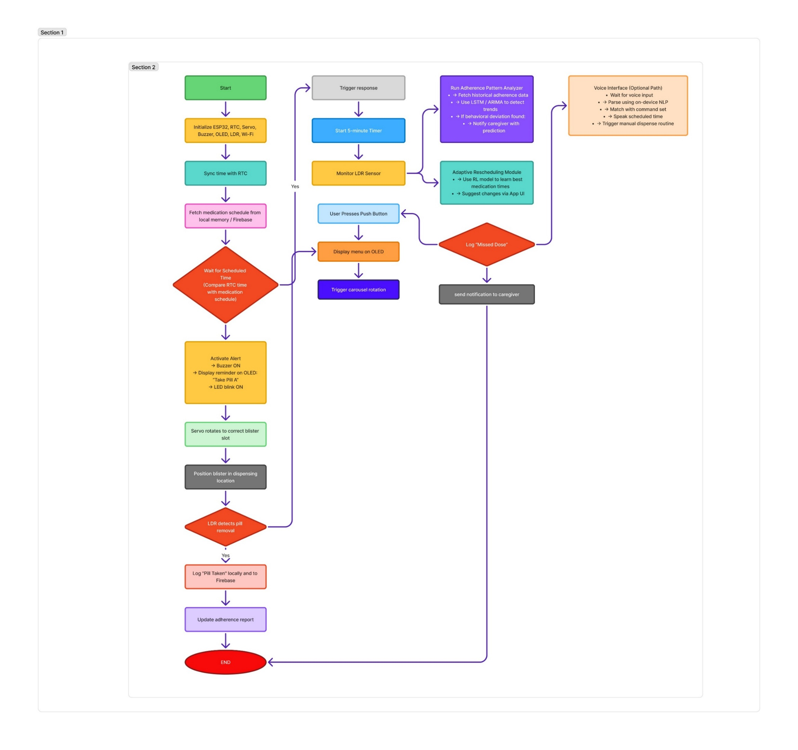

# Claim:

1. The proposed invention is a smart medication dispenser system featuring a rotatory blister pack carousel integrated with artificial intelligence to ensure accurate, timely, and personalized dispensing of medication, particularly targeted toward elderly and chronically ill users. This system comprises a microcontroller (ESP32), servo motors, a real-time clock (RTC), an OLED display, push buttons, a light sensor, and Wi-Fi-based connectivity for adherence tracking and caregiver notifications, thereby ensuring a high level of usability, accessibility, and safety.
2. As stated in claim 1, the system uses a rotatory carousel mechanism capable of holding standard-sized blister packs. Each slot in the carousel is mechanically indexed to align the correct medication at the dispensing portal based on a schedule set via the app or directly on the device. The carousel rotates automatically to position the appropriate pill pack, triggered by the RTC and controlled by the ESP32 microcontroller.
3. As stated in claim 1 and 2, the dispensing process includes real-time adherence tracking using a light-dependent resistor (LDR) sensor placed adjacent to the dispensing slot. The sensor detects whether the medication was removed, and if not within a predefined duration, the system alerts caregivers via a mobile application or SMS. This hands-free, real-time tracking mechanism improves user accountability and mitigates missed doses.
4. As an enhancement to claim 3, artificial intelligence is employed to analyze adherence patterns using time-series forecasting models such as LSTM and ARIMA. These models detect subtle behavior deviations, such as delays in medication intake, enabling preemptive intervention by caregivers before adherence deteriorates.
5. The system further includes adaptive scheduling capabilities. Using reinforcement learning and clustering algorithms, the device automatically adjusts medication timings based on user behavior patterns. For instance, if a user consistently delays a specific dose, the system recommends shifting the schedule accordingly, thereby optimizing compliance and reducing user friction.
6. The mobile application, as part of this invention, provides both patient and caregiver interfaces. Patients receive reminders and confirm dose intake using intuitive large-button interfaces, whereas caregivers receive missed dose alerts and access compliance dashboards. The application supports remote scheduling, emergency overrides, and real-time log access.
7. The invention integrates voice-based interaction through embedded NLP models running on-device (via TensorFlow Lite or equivalent). This allows users to issue commands such as “Remind me in 10 minutes” or “When is my next dose?” and receive audible confirmations. This voice-enabled functionality ensures accessibility for users with visual impairments or limited mobility.
8. To further confirm user adherence, the system optionally supports photo verification via the mobile app. Captured images are analyzed using AI-driven image recognition to validate if the correct medication was taken. This provides an additional compliance layer beyond sensor-based confirmation.
9. The device features robust power management, including rechargeable lithium-ion battery backup and a dedicated coin cell for RTC stability. This ensures continuous operation and schedule tracking even during power outages, a critical advantage over conventional dispensers that lose time-based accuracy under such conditions.
10. The physical housing is modular and hygienically designed, with a user-friendly interface and secure refill mechanism. The carousel accommodates 7 to 14 medication slots, each dimensioned to fit blister packs up to 70mm x 120mm. Its compact footprint (approximately 300mm diameter and 160mm height) enables easy placement on household furniture or clinical environments.
11. This invention also incorporates local data storage and optional cloud-based synchronization. The architecture ensures that logs and schedules are backed up and accessible across devices, enhancing reliability and enabling longitudinal adherence monitoring by healthcare providers.
12. In contrast to existing systems that depend on external servers for processing and suffer latency issues, the proposed system performs all critical functions—including AI-based analytics and sensor data interpretation—locally on the ESP32, leveraging edge computing benefits for real-time responsiveness.
13. The invention supports real-time notifications via multiple channels—app-based alerts, SMS, and email—ensuring redundancy and guaranteed caregiver awareness in case of missed doses. These notifications are customizable and include timestamps, user activity logs, and dosage details.
14. The user interface on the device (OLED display and buttons) is designed for high-contrast visibility and tactile interaction. The interface supports manual dose requests, navigation through menu options, and confirmation of system status, ensuring usability even in non-smartphone environments.
15. In sum, this invention provides a comprehensive, AI-enhanced medication adherence system that goes beyond automated dispensing. It integrates behavioral analytics, environmental independence, and cross-platform caregiver interaction to offer a scalable, real-time solution to medication non-compliance in aging and vulnerable populations.

# Abstract:

The suggested smart medicine dispenser is a cutting-edge medical tool intended to increase geriatric and chronic sickness patients' adherence to their prescription regimens. To guarantee accurate and prompt drug delivery, it has a revolving blister pack carousel controlled by an ESP32 microcontroller, aided by an OLED display, servo motors, several sensors, and a real-time clock. Without depending on cloud connectivity, the system functions autonomously at the edge, guaranteeing improved privacy, faster performance, and dependability even in the event of internet disruptions. Medications can be scheduled via a mobile application or the onboard OLED interface. The gadget moves the carousel to the appropriate slot, distributes the medication, and sounds an alert utilising a buzzer and screen prompt at the appointed time. A carer receives a push notice, SMS, or email if the pill is not retrieved within a predetermined period of time (e.g., five minutes) after a light sensor verifies that it has been taken.The dispenser analyses user behaviour and identifies anomalies, such as often missed doses, using AI models like LSTM and ARIMA to enhance long-term drug adherence. Additionally, it uses reinforcement learning to modify drug schedules according to the user's daily routine, providing a customised and adaptable solution. The mobile application has two interfaces: one for carers that offers real-time logs, adherence trends, and remote override features, and one for patients that contains medication alarms, dose confirmation, and optional photo verification. Users with physical or visual disabilities can interact with the gadget hands-free thanks to a voice-controlled interface that uses embedded NLP models.The dispenser's small size—roughly 300 mm in diameter and 160 mm in height—allows it to be used both at home and in medical facilities. In order to preserve the real-time clock during outages, it has an integrated power backup system that uses a coin-cell battery and a rechargeable battery. All things considered, this smart medication dispenser offers a workable and scalable solution to the pervasive issue of medication non-adherence in geriatric and outpatient care by combining automation, artificial intelligence, real-time communication, and accessibility into a single platform.

# 7. Drawing:

Figure b

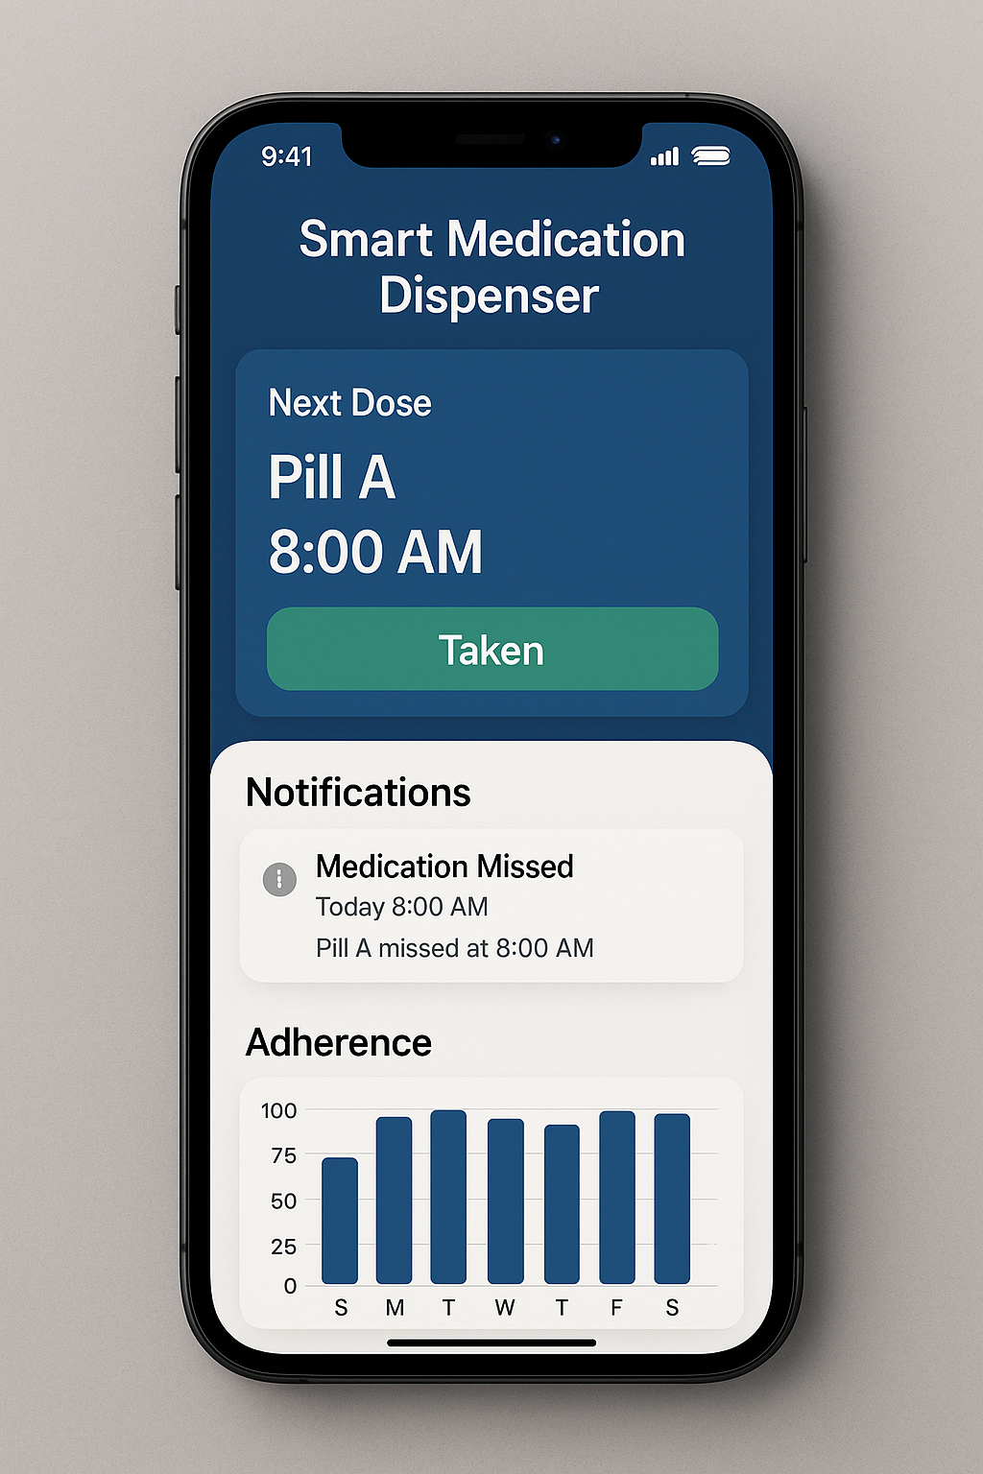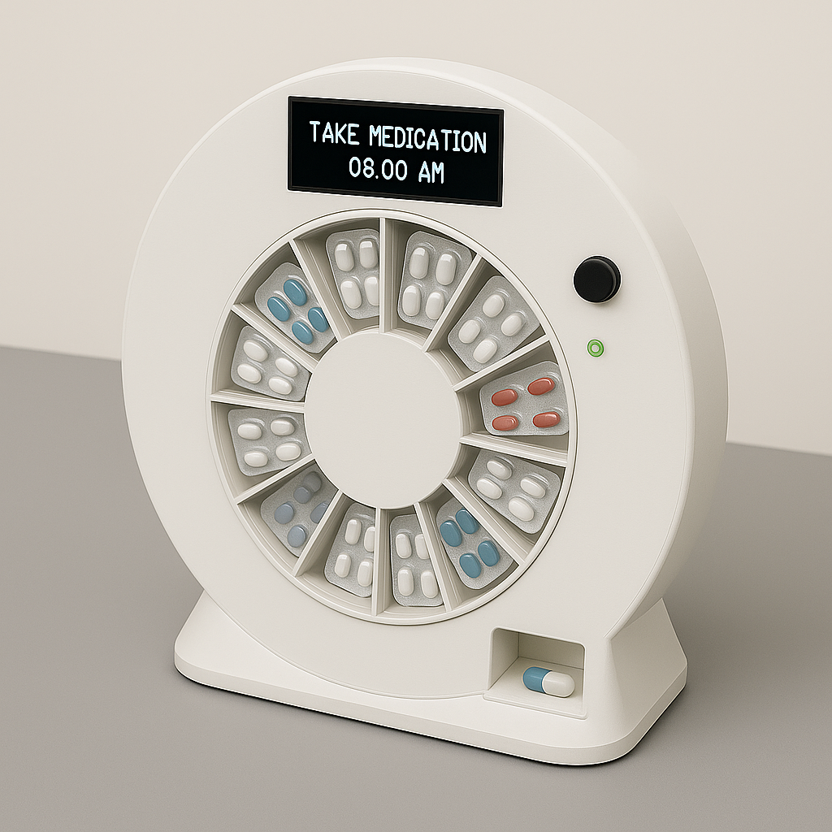

Figure a

Figure c

Figure 1(a): Design of Proposed prototype

Figure 1(b): Design of Proposed prototype depicted along with its hardware components.

Figure 1(c): Screenshot of the mobile application which is connected with the device